Section -7.1

1. Create a simple class Shape that will represent a 2-dimensional shape with line segments for edges. It should have the following instance variables: numSides (int), regular (boolean). Create at least two constructors and getter and setter methods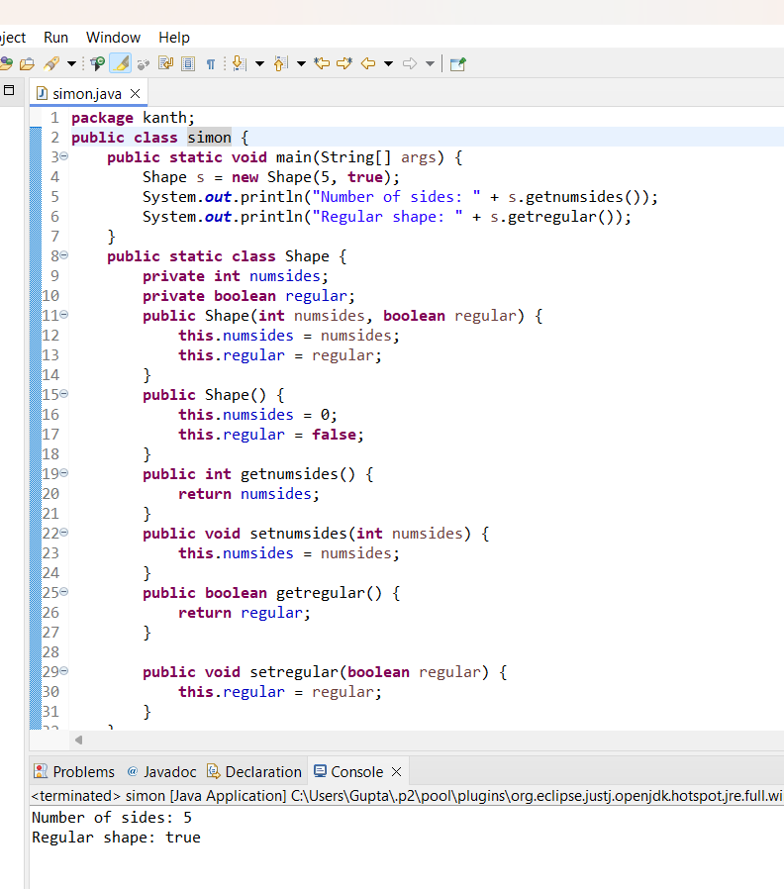

3. Write code to create two instances of the Animal class template listed in problem #2. Be sure to use each of the two constructors provided. Then add Java code that will print the following: a. Animal #1 has a speed of ___. b. Animal #2 has a speed of ___. Be sure that the blanks are automatically filled in with the actual speeds. Use the methods provided to access the speeds.

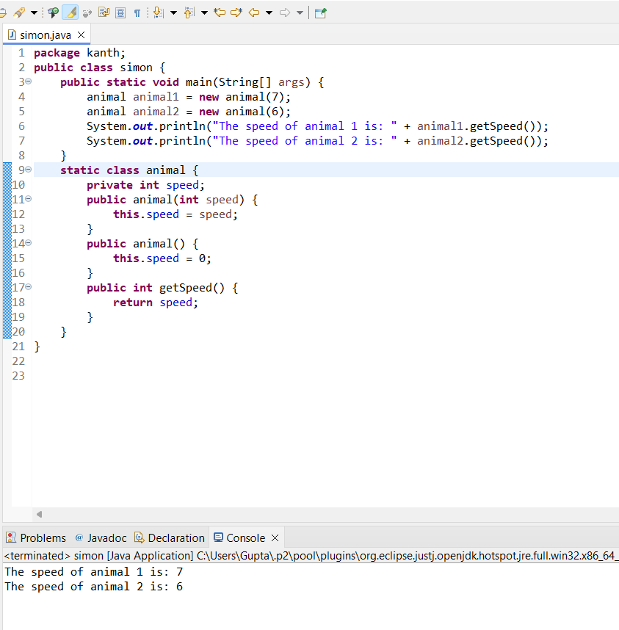

7. Using the Card class from the slides and test the program to make sure it works. Add a second random Card. Code is included below:

public class Card{

String suit,name;

int points;

Card(int n1, int n2){

suit = getSuit(n1);

name = getName(n2);

points = getPoints(name);

}

public String toString(){

return "The " + name + " of " + suit;

}

public String getName(int i){

if(i == 1) return "Ace";

if(i == 2) return "Two";

if(i == 3) return "Three";

if(i == 4) return "Four";

if(i == 5) return "Five";

if(i == 6) return "Six";

if(i == 7) return "Seven";

if(i == 8) return "Eight";

if(i == 9) return "Nine";

if(i == 10) return "Ten";

if(i == 11) return "Jack";

if(i == 12) return "Queen";

if(i == 13) return "King";

return "error";

}

public int getPoints(String n){

if(n == "Jack" ||n == "Queen" ||n == "King"||n == "Ten") return 10;

if(n == "Two") return 2;

if(n == "Three") return 3;

if(n == "Four") return 4;

if(n == "Five") return 5;

if(n == "Six") return 6;

if(n == "Seven") return 7;

if(n == "Eight") return 8;

if(n == "Nine") return 9;

if(n == "Ace") return 1;

return -1;

}

public String getSuit(int i){

if(i == 1) return "Diamonds";

if(i == 2) return "Clubs";

if(i == 3) return "Spades";

if(i == 4) return "Hearts";

return "error";

}

}

public class Main {

public static void main(String args[]){

int suitNumber = (int)(Math.random()*4.0+1);

int faceNumber = (int)(Math.random()*13.0+1);

Card newCard = new Card(suitNumber,faceNumber);

System.out.println(newCard);

}

Code

} 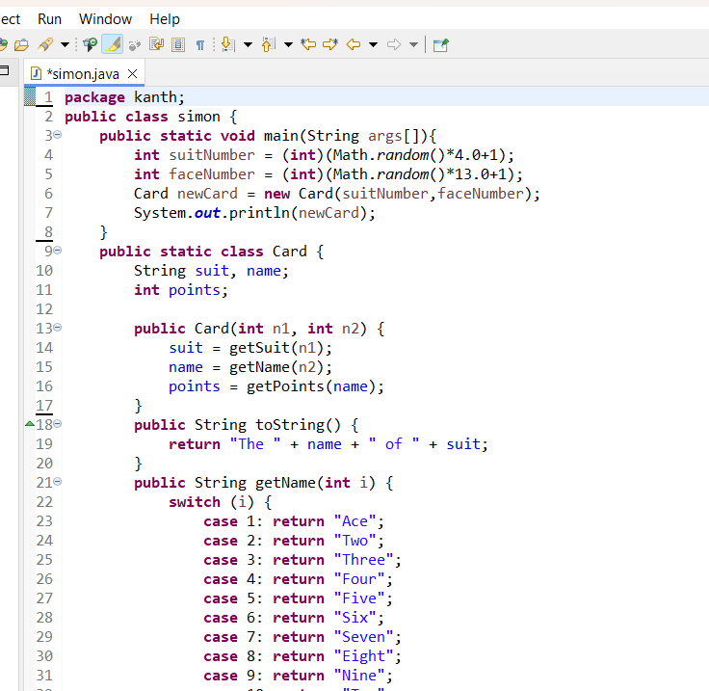

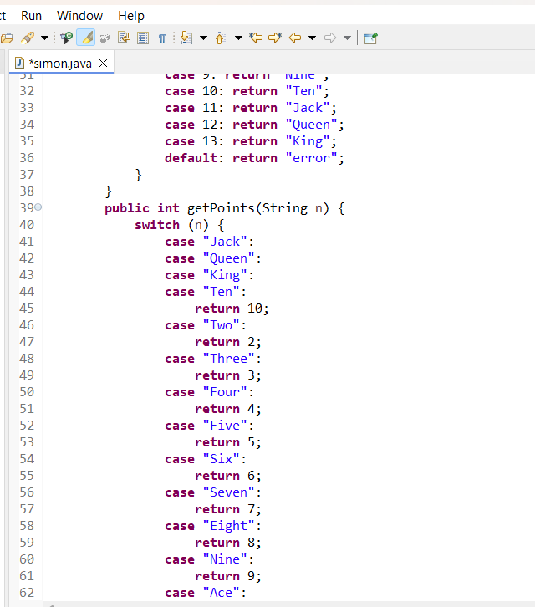

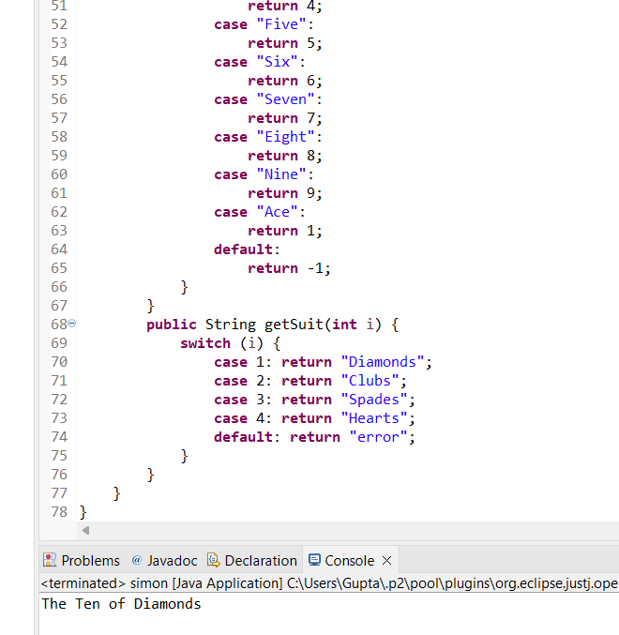

8. Add code to the Main class in exercise #7 to the following:

a. Display the total point value for the two random cards.

b. Ask the user if they would like another card. If they say yes display the new card and the points for all 3 cards in their “Hand”.

c. Loop to allow the user to continue to add cards to the hand until the number of points goes over 21 or the user decides not to add any more cards or the total number of cards is 5.

